**PROOF OF CONCEPT**

**Submitted By: Valluru Sri Priya**

**BT17GCS119**

1. **Recommended Platform:**

According to me, the best platforms are Hyper Ledger and Ethereum. But there is small difference between these two platforms. Ethereum runs the smart contracts on the EVM for the applications that are attributed and are decentralized. Hyperledger leverages blockchain technology which is very flexible in the way we use. The biggest advantage in Hyperledger fabric is we can create channels in order to safe an organizations asset. Because, if there are any two organizations which are competing with each other. Both decide to not give public access to all the peers to contact. So, In Hyperledger fabric, We can create a channel where a set of peers can only get contacted and exchange the transactions among them. Also, we can write the edit the code in either js, go, java in Hyperledger. Based on both the platforms, Ethereum is little bit slower where I have observed in my PC. So, I recommend Hyperledger as it is very interesting and can code a smart contract in any of the 3 languages.

1. **Project Plan:**

I wish I had submitted the project before the timeline. But, because of some issues, I have not. I have done the coding on 23rd, Nov 2020. I had gone through all the references on 22nd , Nov 2020.

**References:**

1. <https://hyperledger-fabric.readthedocs.io/en/release-2.2/write_first_app.html>
2. https://hyperledger-fabric.readthedocs.io/en/release-2.2/whatis.html
3. **UML USE CASE Diagram:**

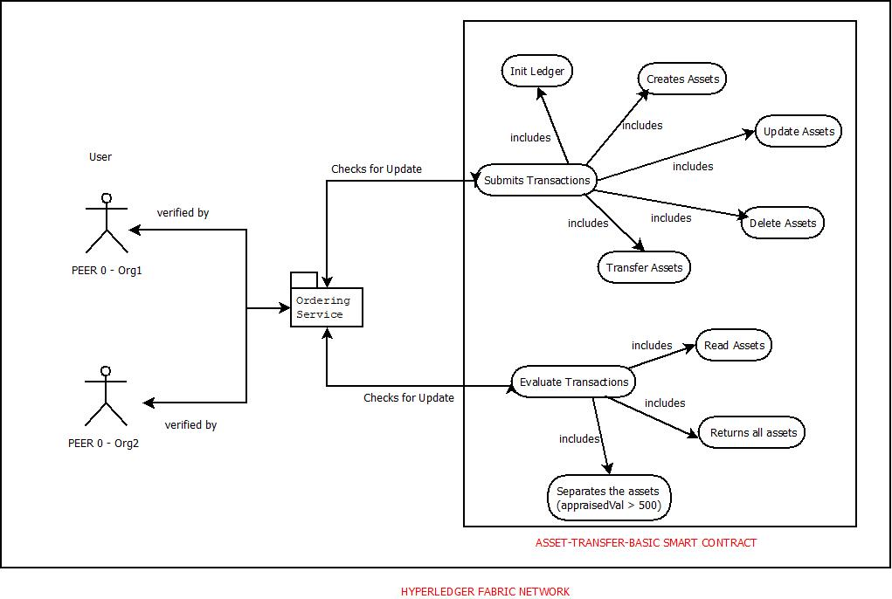

**d) Code:**

In order to write a new function, we need to edit the assetTranfer.js file which is in the /chaincode-javascript/lib/. Here, as show in the below figure, I have mentioned a new function named “AssetGreaterThanX” which results all the assets having the appraised value greater than X. If the if condition is satisfied, then all the results are appended to a constant named allResults.

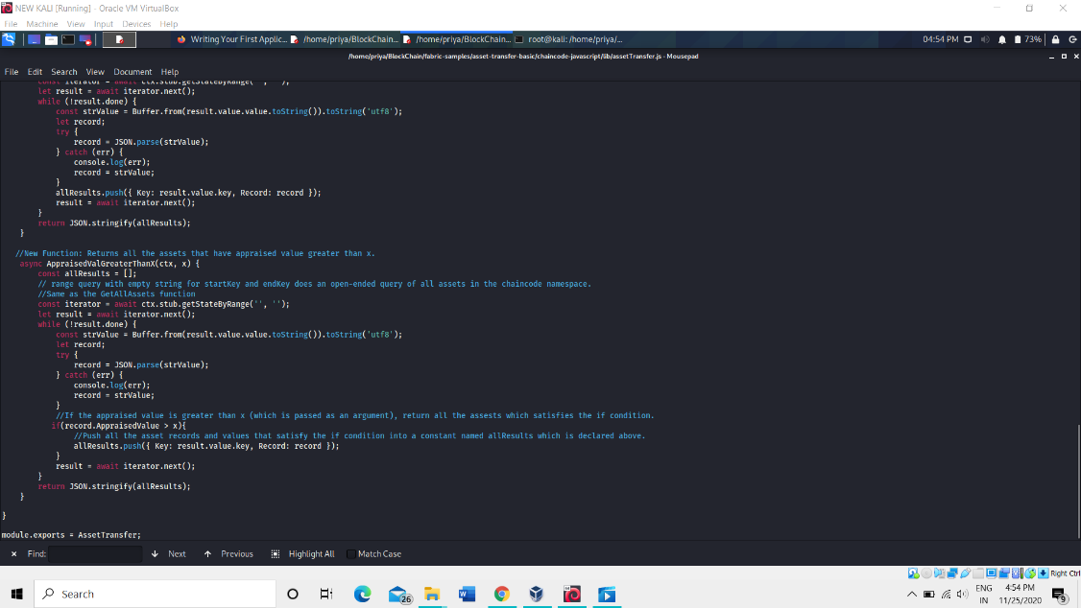

In app.js file we need to call the function which we have written in the assetTransfer.js file. And we need to pass an argument “x” which is appraised value that we need to pass.

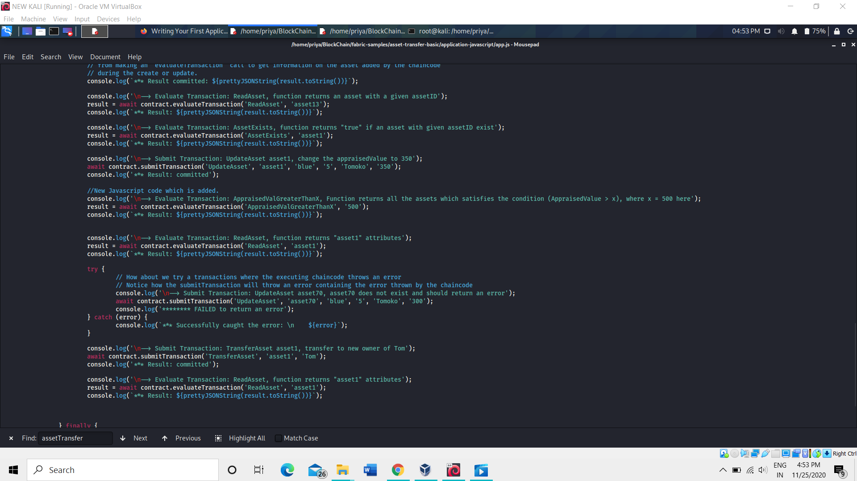

**Result:**

